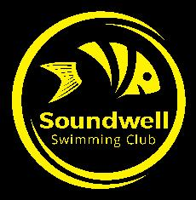
Soundwell Shop

New
Speedo Performance Power Hand Paddles Size Medium (Adult) £12.50
Speedo Performance Power Hand Paddles Size Large (Adult) £12.50
Mad Wave Paddles Finger Pro Swimming Paddles (One Size) £7.50
Speedo Mesh Kit Bag (Yellow, Navy or Black) £7.50
Soundwell Swimming Hat £6
Speedo Noseclip – one size £4.99
Ear Bands (for ear protection) – Junior and Senior sizes £4.99

Second Hand
Kiefer Long Fins Size 5.5-6 £5
Kiefer Long Fins Size 1-2 £5
Mad Wave Long Fins Size 11-1 £5
Mad Wave Short Fins Size 5-7 £5

